**Question:**

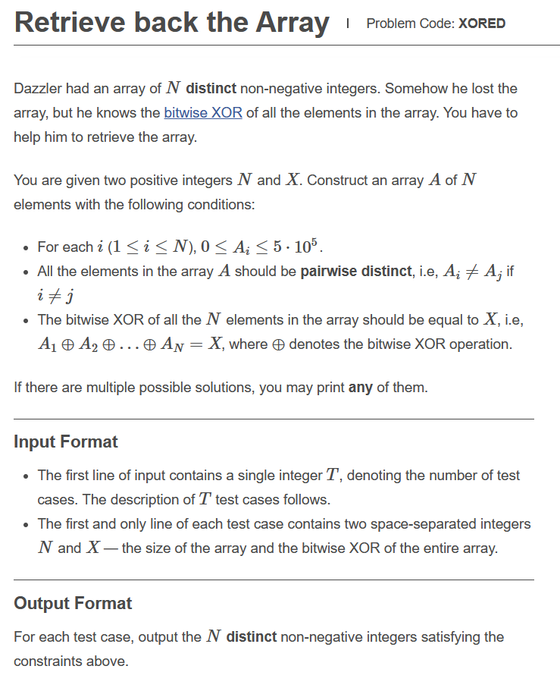

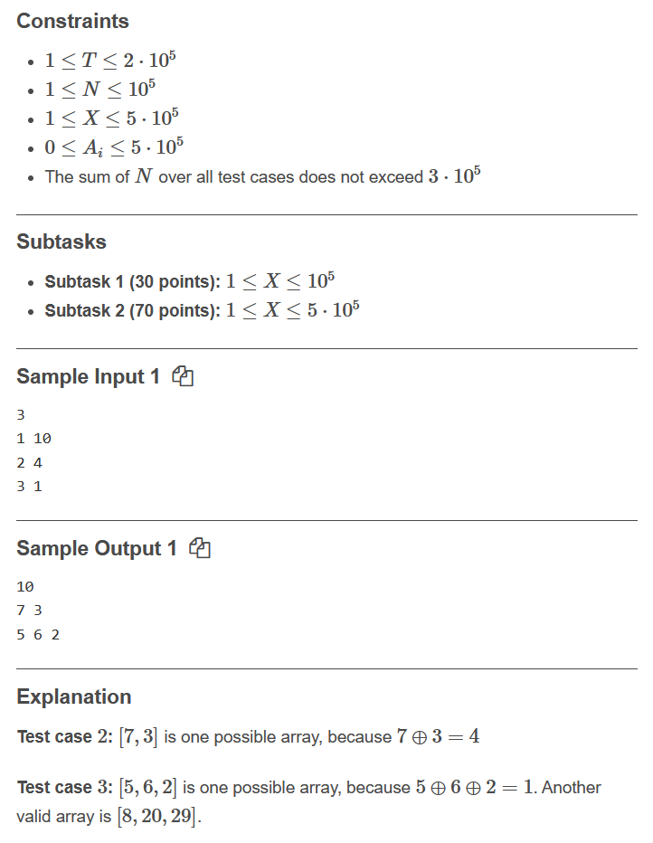

**Link: https://www.codechef.com/JAN221C/problems/XORED**

**Code:**

**#include<bits/stdc++.h>**

**#define ll long long**

**using namespace std;**

**int main()**

**{**

**int input;**

**cin>>input;**

**for(int q=0;q<input;q++)**

**{**

**ll n,k;**

**cin>>n>>k;**

**vector<ll> vec;**

**map<ll,ll> mape;**

**ll spain=0;**

**for(ll i=0;i<n-2;i++)**

**{**

**vec.push_back(i);**

**mape[i]=1;**

**spain=spain^i;**

**}**

**ll i=(n-2);**

**while(1)**

**{**

**if(spain==k)**

**{**

**mape[vec[n-2]]=0;**

**vec.pop_back();**

**i++;**

**mape[i]=1;**

**vec.push_back(i);**

**spain=(spain^(n-3))^i;**

**}**

**else**

**break;**

**}**

**ll spain1=spain^k^i;**

**ll qq=1;**

**while(qq)**

**{**

**if(mape[spain1]!=0 || spain1==i || spain1>(500000))**

**{**

**i++;**

**spain1=spain^i^k;**

**}**

**else**

**{**

**vec.push_back(i);**

**vec.push_back(spain1);**

**break;**

**}**

**}**

**if(n==1)**

**{**

**cout<<k<<endl;**

**}**

**else**

**{**

**for(ll i=0;i<n;i++)**

**cout<<vec[i]<<" ";**

**cout<<endl;**

**}**

**}**

**return 0;**

**}**

**Solution: Correct(100 points)**